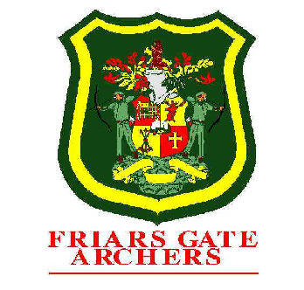
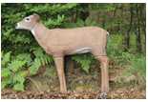
FRIARS GATE ARCHERS

3D Shoot
Sunday 11th May 2025

www.friarsgatearchers.com

Round: | 3D Round – 24 targets  .
Location: | Newnham Park, near Crowborough, East Sussex  For sat-nav users the nearest available postcode is TN6 3TB  Location map is available on our website  What Three Words App: flip.outermost.taking
Assembly: | 0930 am Shooting will start at 10.00 am
Entry Fees: | Adults: £15.00 Juniors: £10.00  Please note that this event is only open to current members of AGB.  Sort Code: 40-18-39 Account No: 31036327 Friars Gate Archers  NEW CODE: FLD (surname)
Closing Date: | Midnight Saturday 3rd May 2025
Refreshments: | Only tea and coffee will be available at this shoot
Bowstyle: | All bow styles are permitted on this site.  If your bowstyle is different from original booking form on the day of the shoot, please let me know to avoid embarrassment on results.
Privacy Notice: | Please read and tick Data box on booking form if you would like your contact information kept. Applies to all archers.

